1. Loading MNIST dataset locally
mnist.npz file will be provided to you
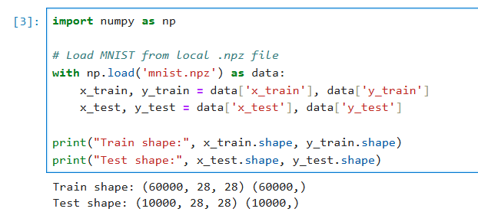

2. Loading fasterrcnn_weights locally
.pth file will be provided to you
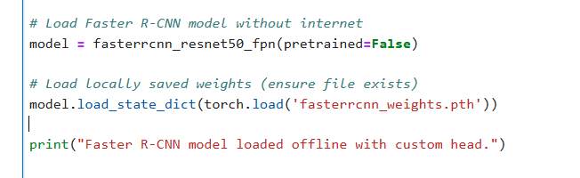

3. Loading resent model locally
H5 file will be provided to you
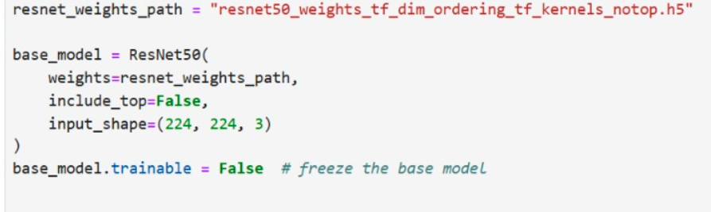

4.Loading vgg16
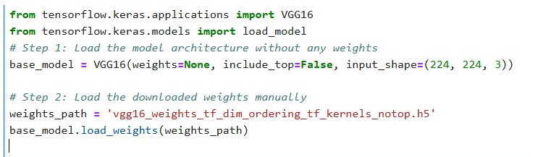
6.Loading cifar 10
